CSC-201L Information Security
Data Privacy Audit Tool for Websites
Project Report
Section: A



Submitted By:
Syed Shayan Arshad 2023-CS-625
Adeel-Ur-Rehman 2023-CS-626
Hammad Khalid 2023-CS-637

Submitted To:
Mam. Shanfa
Dated: 04th May 2025

Department of Computer Science
University of Engineering and Technology Lahore, New Campus
Abstract
The Website Privacy and Security Audit Tool is a web application designed to evaluate websites for privacy and security compliance, focusing on standards like GDPR, CCPA, and general web security best practices. It scans websites for privacy policies, cookie usage, data collection practices, form security, SQL injection vulnerabilities, and SSL/TLS configurations. Built using Python, Flask, and various security libraries, the tool provides users with a detailed report highlighting compliance issues, vulnerabilities, and recommendations for improvement. The system incorporates robust security measures, such as encrypted storage of user payment information and secure user authentication, ensuring data protection. This project aims to help website owners and developers ensure their sites adhere to privacy regulations and maintain secure environments.
Introduction
In today’s digital world, websites collect vast amounts of user data, making privacy and security critical concerns. Regulations like the General Data Protection Regulation (GDPR) and California Consumer Privacy Act (CCPA) mandate strict guidelines for data collection, storage, and user consent. Additionally, security vulnerabilities like SQL injection, insecure forms, or weak SSL configurations can expose websites to attacks. The Website Privacy and Security Audit Tool addresses these challenges by providing an automated, user-friendly platform to audit websites for compliance and security.
The tool scans a website’s:
- Privacy Policy: Checks for the presence and quality of a privacy policy.
- Cookies: Analyzes cookie usage and consent mechanisms.
- Data Collection: Identifies trackers and data collection practices.
- Form Security: Evaluates forms for secure data transmission.
- SQL Injection: Tests for vulnerabilities in form inputs.
- SSL/TLS Security: Verifies HTTPS usage, certificate validity, and secure headers.
- Compliance: Assesses adherence to GDPR and CCPA regulations.
The project incorporates information security principles, such as encryption (AES and RSA), secure password hashing, and token-based authentication for sensitive data access. It is designed for website owners, developers, and privacy enthusiasts to ensure their sites are secure and compliant.
Tech Stack and Libraries
The tool is built using a combination of modern technologies and libraries, ensuring scalability, security, and ease of use. Below is the tech stack and the purpose of each component:
Backend
- Python 3: The core programming language for implementing the scanning logic and server-side functionality.
- Flask: A lightweight web framework for building the web application, handling routes, and rendering templates.
- SQLite: A lightweight database for storing user data, audit records, and encrypted payment information.
- Selenium: Used for dynamic content scraping and form interaction, enabling the tool to analyze JavaScript-rendered pages.
- Requests: For making HTTP requests to fetch web pages and check external resources.
- BeautifulSoup: For parsing HTML content and extracting relevant data like forms, links, and scripts.
- Cryptography: Provides AES and RSA encryption for securing sensitive data like credit card details.
- Hashlib: For secure password hashing using SHA-256 with salts.
- Secrets: For generating secure random tokens and salts.
- Flask-Login: Manages user authentication and session handling.
- Threading: For running scans within a timeout to prevent long-running processes.
Frontend
- HTML/CSS/JavaScript: For creating user interfaces (assumed to be in the templates: index.html, login.html, register.html, results.html, upgrade.html, profile.html).
- Tailwind: For responsive and styled UI components in the templates.
Database
- SQLite: Stores user information, audit history, payment details, and encryption keys in tables
Information Security Focus
- Encryption: Uses AES-CBC for credit card encryption and RSA for key encryption, ensuring sensitive data is protected.
- Password Hashing: SHA-256 with unique salts per user prevents password cracking.
- Token-Based Access: Temporary tokens secure access to unmasked payment details.
Functional Features
1. Privacy Policy Scanner
Purpose: Checks if a website has a privacy policy, analyzes its content, and evaluates its quality.
Implementation:
- Finding the Policy: The tool first checks for privacy policy URLs by scraping the webpage using BeautifulSoup to find links containing keywords like “privacy,” “policy,” or “data protection” in the href or text. Relative URLs are converted to absolute using urljoin.
- Fetching Content: The tool uses Selenium to load the policy page, handle consent dialogs, and scroll for dynamic content. If Selenium fails, it falls back to Requests to fetch the HTML.
- Analyzing Content: The policy text is extracted and searched for key elements (e.g., data collection, data use, user rights) using regex patterns. For example, terms like “collect,” “personal,” or “information” indicate data collection.
- Last Updated Date: Regex patterns search for phrases like “Last Updated” or “Effective” to extract the policy’s update date. If the date is over a year old, it’s marked as outdated.
- Scoring: A score is calculated based on the presence of required elements (50%), recommended elements (40%), and a recent update date (10%). Missing elements trigger recommendations.
Security Aspects:
- Ensures websites disclose data practices, a key GDPR/CCPA requirement.
- Robust error handling prevents crashes from malformed pages.
- Secure HTTP requests with user-agent headers avoid blocking.
2. Cookie Scanner
Purpose: Identifies and categorizes cookies, checks for GDPR-compliant consent mechanisms.
Implementation:
- Cookie Detection: Uses Selenium to get browser cookies and Requests to capture HTTP cookies, combining them to avoid duplicates.
- Categorization: Cookies are classified as necessary, functional, analytics, advertising, or unclassified based on their names and a predefined database. Keywords like “ad” or “track” help categorize.
- Consent Check: Searches for consent banners using keywords (“accept cookies,” “GDPR”) and checks for granular controls (checkboxes/radios) using XPath and CSS selectors.
- Results: Reports the total cookies, their categories, percentages, and consent compliance status.
Security Aspects:
- Ensures GDPR compliance by verifying consent mechanisms.
- Prevents duplicate cookies, improving accuracy.

3. Data Collection Scanner
Purpose: Detects third-party trackers and forms collecting sensitive data.
Implementation:
- Tracker Detection: Scans scripts, links, images, and iframes for third-party domains (e.g., doubleclick.net, google-analytics.com) using a predefined tracker database. Performance logs from Selenium capture additional resources. Domains are categorized as advertising, analytics, social, essential, or other.
- Form Detection: Identifies forms with sensitive fields (e.g., email, password) and checks for consent checkboxes.
- Recommendations: Suggests reducing trackers, adding consent checkboxes, or auditing cookies.
4. Form Security Checker
Purpose: Ensures forms collecting sensitive data are secure (use HTTPS, have CSRF protection).
Implementation:
- Form Detection: Uses BeautifulSoup and Selenium to find forms and their inputs (text, password, etc.).
- Sensitive Fields: Checks for fields like “password,” “email,” or “creditcard” using a predefined list. Inputs are marked sensitive if their name, ID, or type matches.
- Security Checks: Verifies if the form’s action URL uses HTTPS and checks for CSRF tokens in POST forms. Autocomplete settings are also evaluated.
Security Aspects:
- Prevents data leaks by ensuring HTTPS usage.
- Protects against CSRF attacks with token checks.
5. SQL Injection Detector
Purpose: Tests forms for SQL injection vulnerabilities.
Implementation:
- Form Detection: Identifies forms and their input fields, skipping non-text inputs (e.g., checkboxes).
- Payload Testing: Submits payloads like "' OR '1'='1" or "admin' --" to form fields using Selenium for POST forms or Requests for GET forms.
- Error Detection: Checks responses for SQL error patterns (e.g., “MySQL syntax error,” “PostgreSQL ERROR”) using regex.
Security Aspects:
- Simulates real-world attacks to identify vulnerabilities.
- Uses controlled payloads to avoid damaging websites.
- Securely logs test results without storing sensitive data.
6. SSL Security Checker
Purpose: Verifies HTTPS usage, certificate validity, security headers, and cookie attributes.
Implementation:
- HTTPS Check: Ensures the website uses HTTPS.
- Certificate Analysis: Connects to the server via SSL to retrieve certificate details (issuer, expiry, algorithm). Retries handle connection issues.
- Security Headers: Checks for headers like HSTS, CSP, X-Frame-Options using Requests.
- Cookie Security: Verifies cookies have Secure attributes via Selenium.
- Mixed Content: Scans for HTTP resources (scripts, images) on HTTPS pages using BeautifulSoup.
- Scoring: Awards points for HTTPS (30%), valid certificates (40%), headers (20%), and secure cookies/no mixed content (10%).
Security Aspects:
- Ensures end-to-end encryption with HTTPS and valid certificates.
- Secures cookies against interception and CSRF.
7. GDPR and CCPA Compliance Checkers
Purpose: Evaluates compliance with GDPR and CCPA regulations.
Implementation:
- GDPR Checker:
  - Verifies privacy policy presence, data collection/use disclosure, user rights, and cookie consent.
  - Checks forms for consent checkboxes with explanatory text.
  - Falls back to checking common GDPR paths (/gdpr, /privacy) if no policy is found.
- CCPA Checker:
  - Ensures privacy policy, personal info disclosure, consumer rights, and opt-out mechanisms.
  - Checks for “Do Not Sell” links or pages.
  - Similar scoring as GDPR.
- Recommendations: Suggests adding missing policy elements or consent mechanisms.
Security Aspects:
- Aligns with legal standards to protect user data.
- Securely fetches compliance pages with timeouts.
8. User Authentication and Payment System
Purpose: Manages user accounts, authentication, and secure payment storage.
Implementation:
- Registration/Login: Users register with a username, email, and password. Passwords are hashed with SHA-256 and unique salts. Flask-Login manages sessions.
- Premium Upgrade: Users enter payment details (name, card number, CVV), validated server-side (Luhn algorithm for cards, CVV length check). Details are encrypted using AES-CBC (user-specific key) and RSA (for CVV and keys).
- Sensitive Data Access: Accessing unmasked payment info requires password re-verification, generating a 5-minute token stored in database
- Database: SQLite stores user data, audits, and encrypted payment info. The table holds AES keys/IVs encrypted with RSA.
Security Aspects:
- Prevents brute-force attacks with secure hashing.
- Protects payment data with layered encryption (AES+RSA).
- Limits sensitive data exposure with short-lived tokens.
- Validates inputs to prevent injection or fraud.
9. Report Generation
Purpose: Generates a PDF report summarizing scan results.
Implementation:
- Takes scan results from WebsiteScanner and formats them into a structured PDF using ReportLab library.
- Includes sections for privacy policy, cookies, data collection, compliance, form security, SQL injection, and SSL security.
- Saves the PDF in the static/reports folder with a unique Id.
- Available only to premium users, enforced in the /download route.
Security Aspects:
- Restricts report access to authenticated premium users.
- Uses unique report IDs to prevent unauthorized access.
- Securely stores files in a server-controlled directory.
User Guide/Interface
The tool’s interface is designed to be intuitive, guiding users through registration, scanning, and viewing results. Below is a description of each page and where to include screenshots.
1. Home Page
- Purpose: Introduces the tool and allows users to start a scan or log in/register.
- Features:
  - A form to enter a website URL for scanning.
  - Links to login/register for existing/new users.
  - A brief description of the tool’s capabilities.
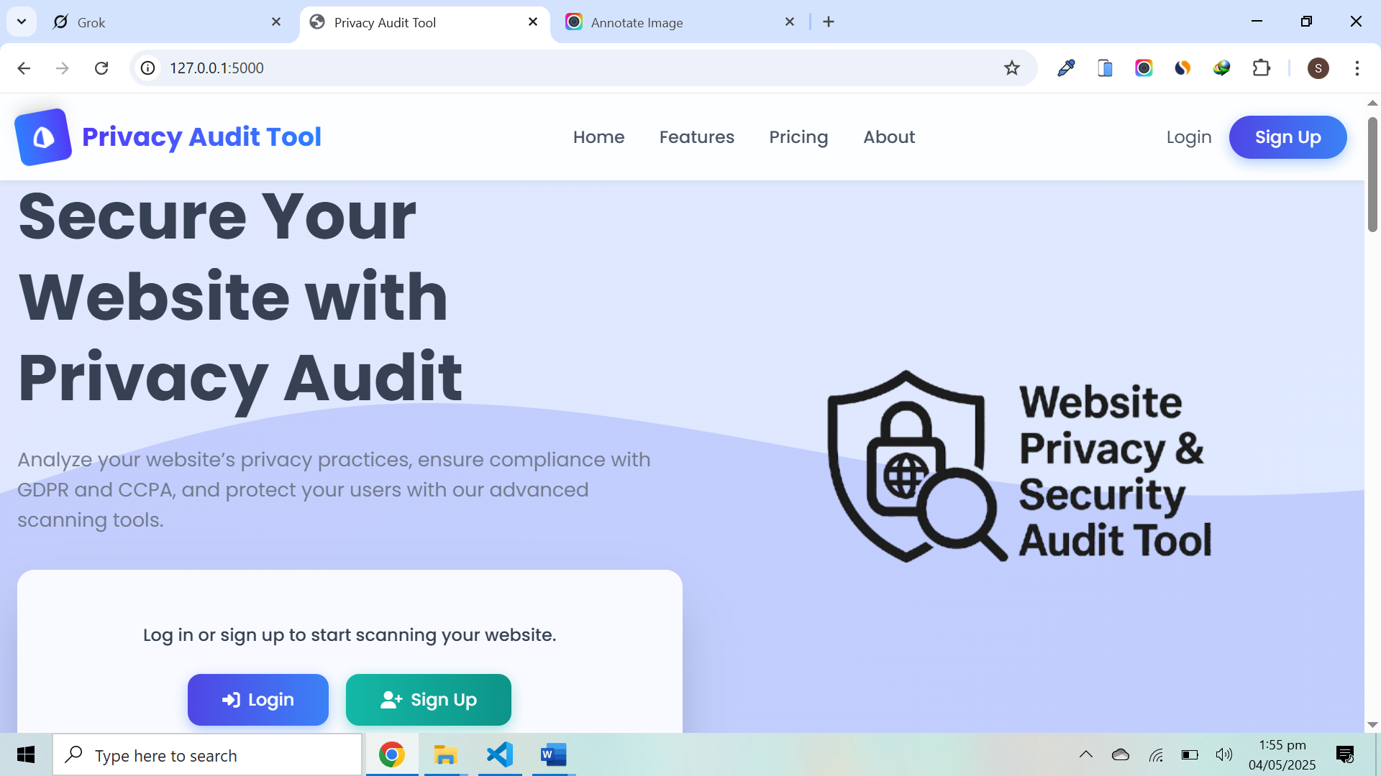
2. Registration Page
- Purpose: Allows new users to create an account.
- Features:
  - Input fields for username, email, password, and confirm password.
  - Client-side validation for password length (8+ characters) and matching.
  - Error messages for duplicate usernames/emails or invalid inputs.
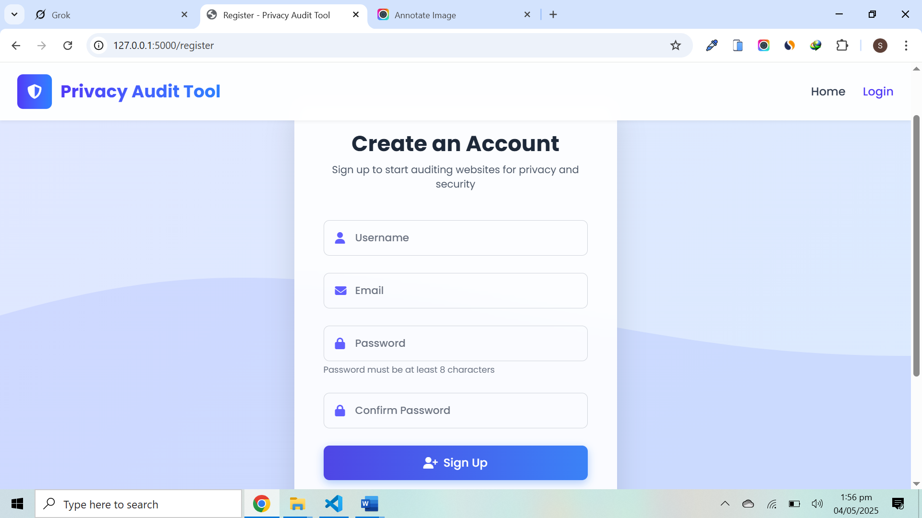
3. Login Page
- Purpose: Authenticates existing users.
- Features:
  - Fields for username and password.
  - Error messages for incorrect credentials.
  - Link to register for new users.
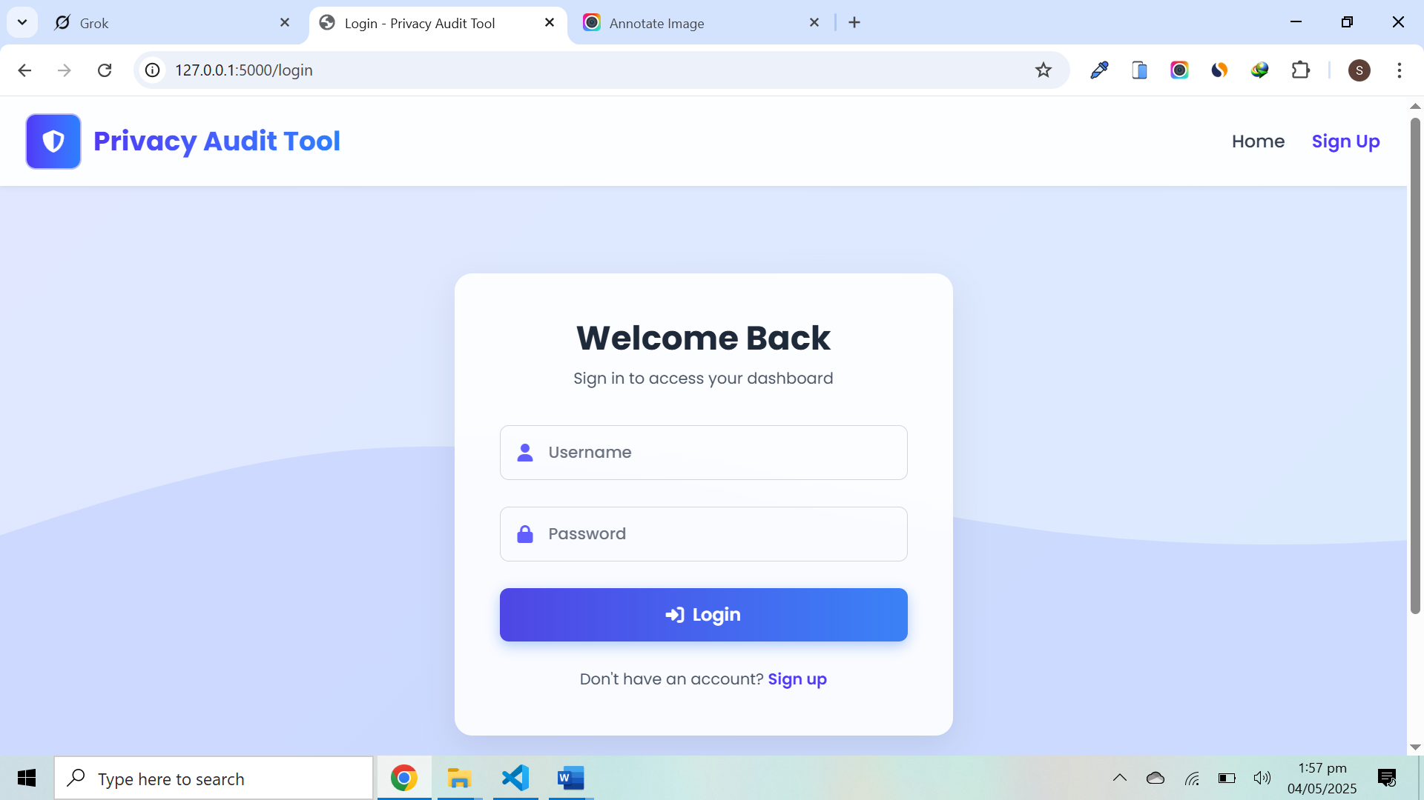
4. Profile Page
- Purpose: Displays user details and audit history.
- Features:
  - Shows username, email, and premium status.
  - Lists past audits with URLs, report IDs, and scan dates.
  - Links to upgrade to premium or download reports (for premium users).
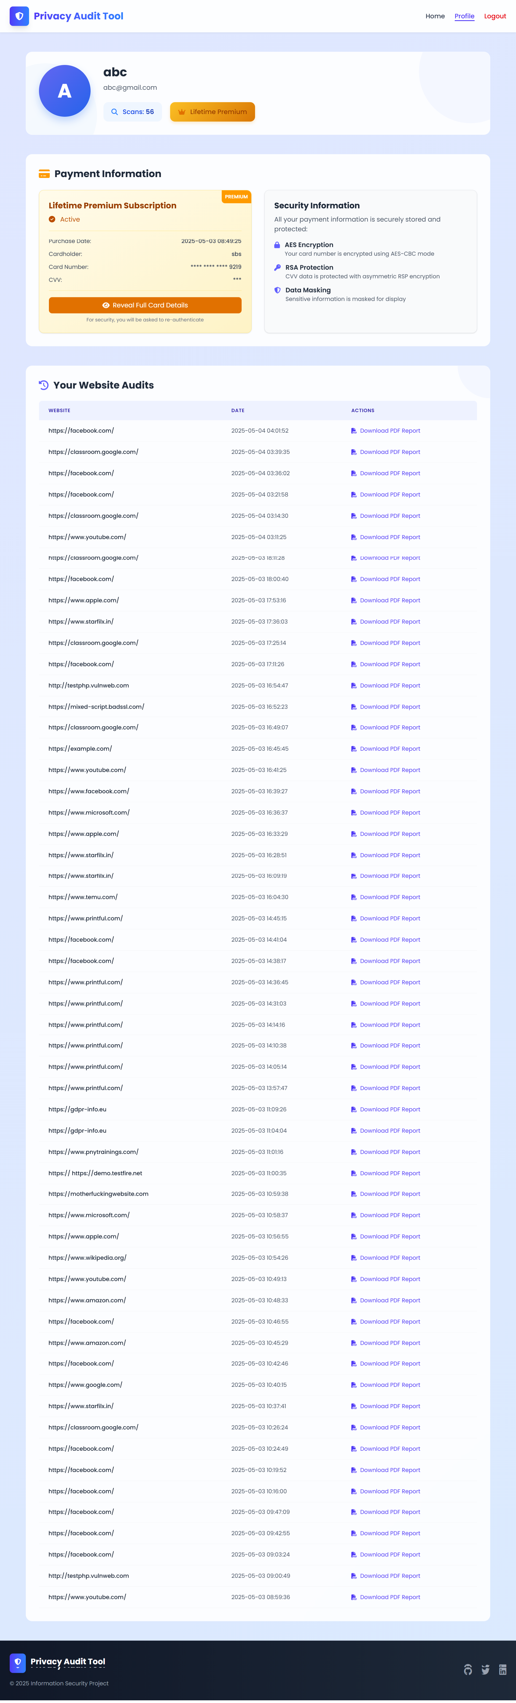
5. Upgrade Page
- Purpose: Allows users to upgrade to premium for unlimited audits and PDF reports.
- Features:
  - Form for name, card number, and CVV.
  - Client-side validation for card format and CVV length.
  - Success/error messages for payment processing.

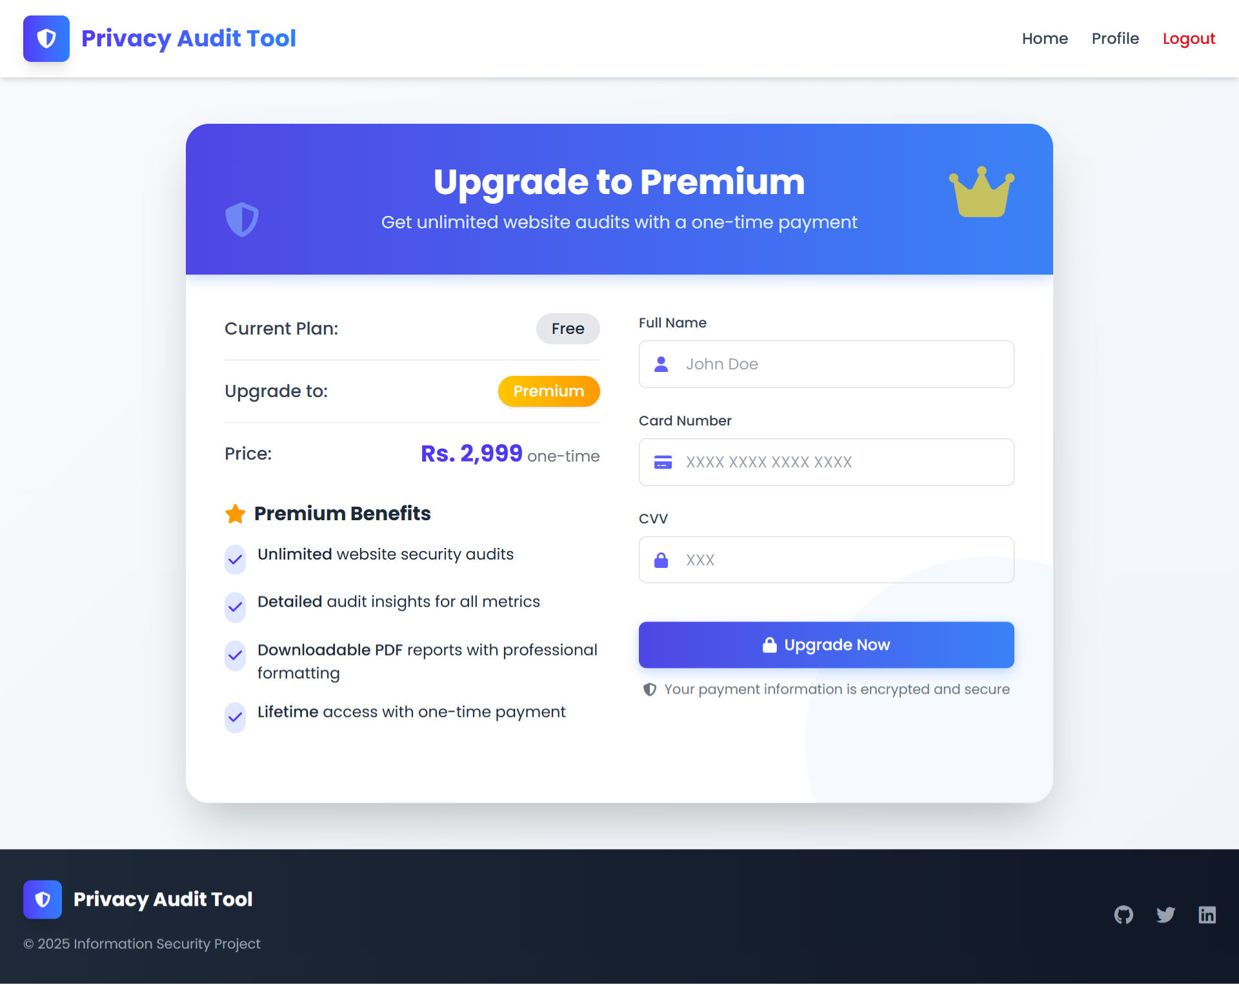

6. Results Page
- Purpose: Displays scan results and recommendations.
- Features:
  - Summarizes overall score, rating, and score class (good/warning/danger).
  - Sections for privacy policy, cookies, data collection, GDPR/CCPA, form security, SQL injection, and SSL security.
  - Recommendations for each section.
  - Download button for PDF report (premium users only).
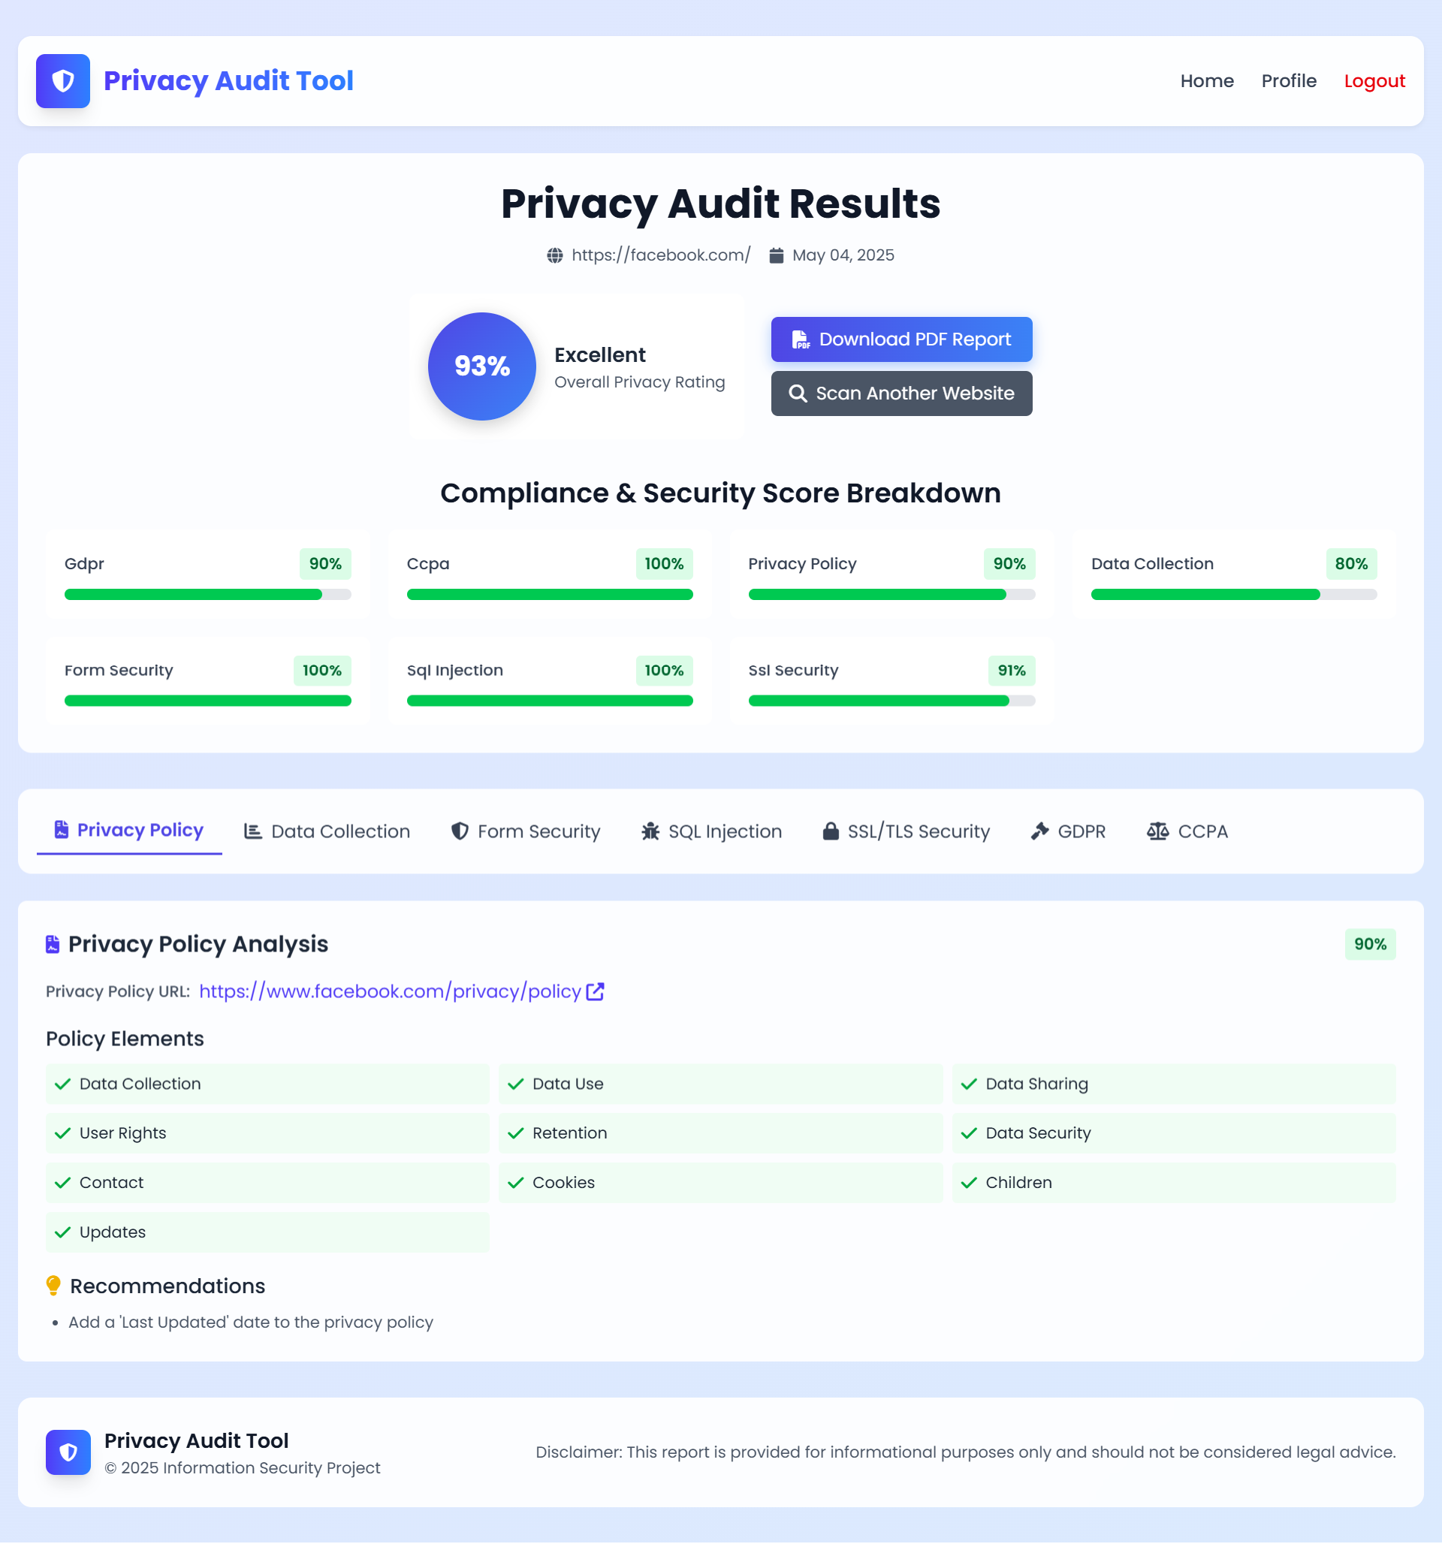
Testing
For testing, we analyze the functionality of tool by using different websites urls and measure performance matrices.
Suggested Websites for Testing
- Large, Compliant Website: https://www.google.com
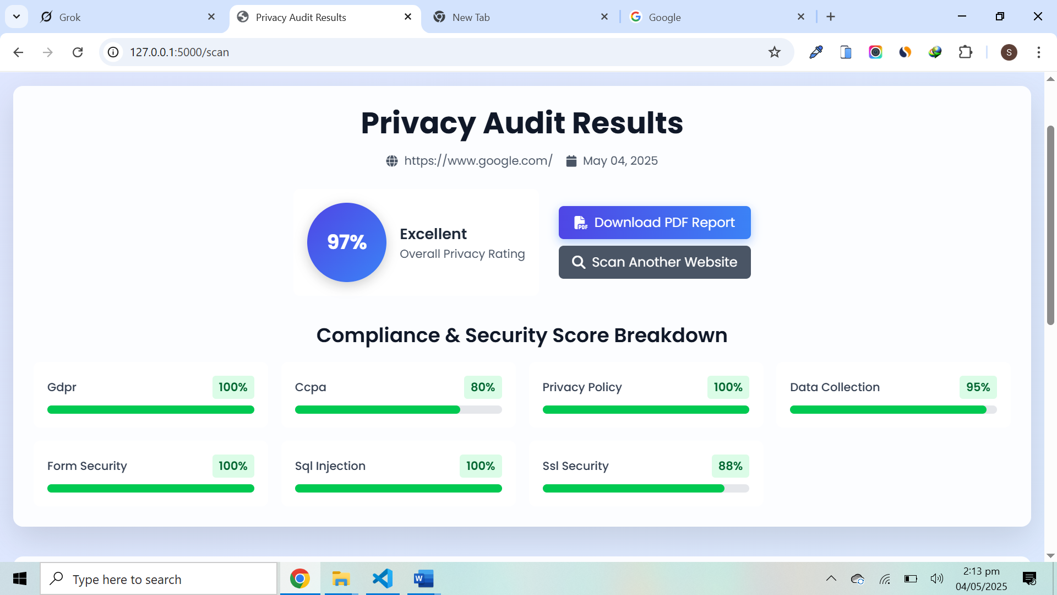
- E-commerce Site: https://www.amazon.com
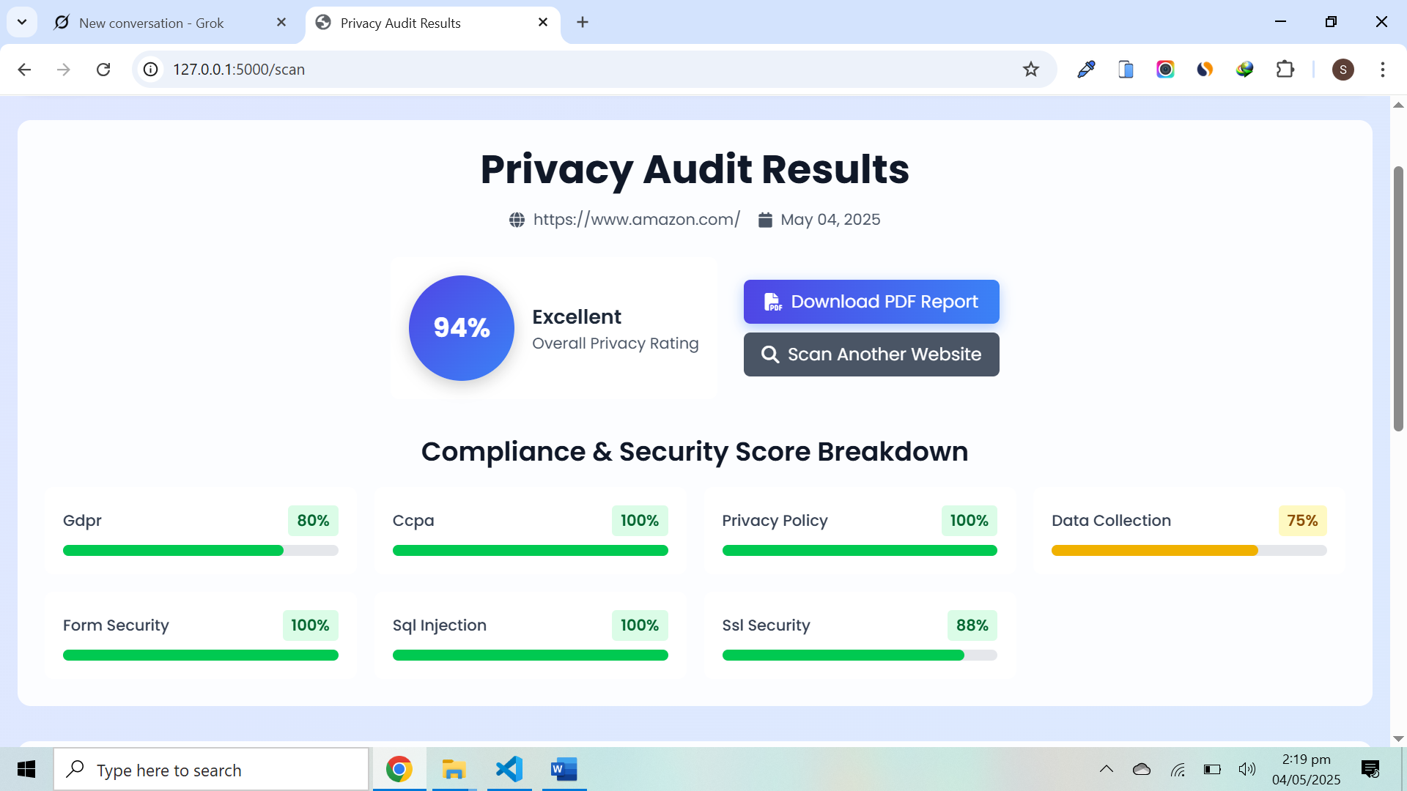
- Small Business Site: https://example.com
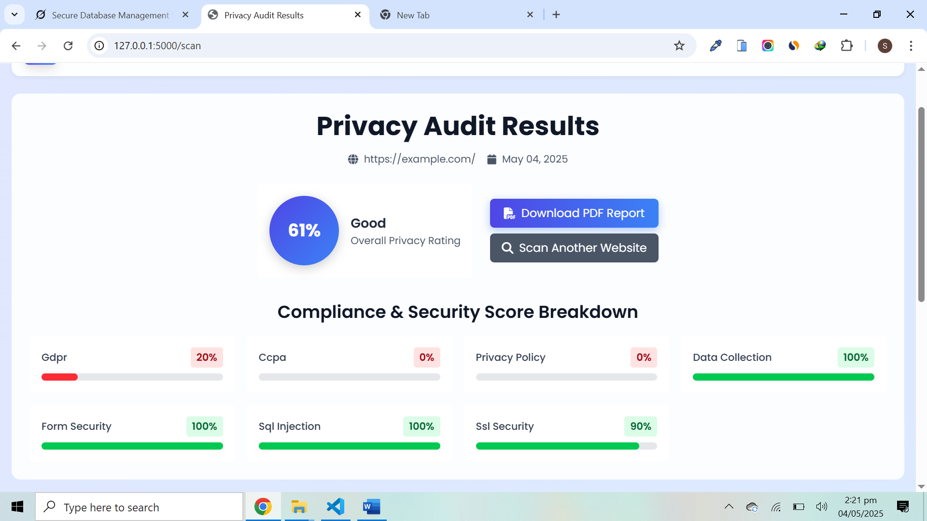
- Vulnerable Test Site: https://testphp.vulnweb.com
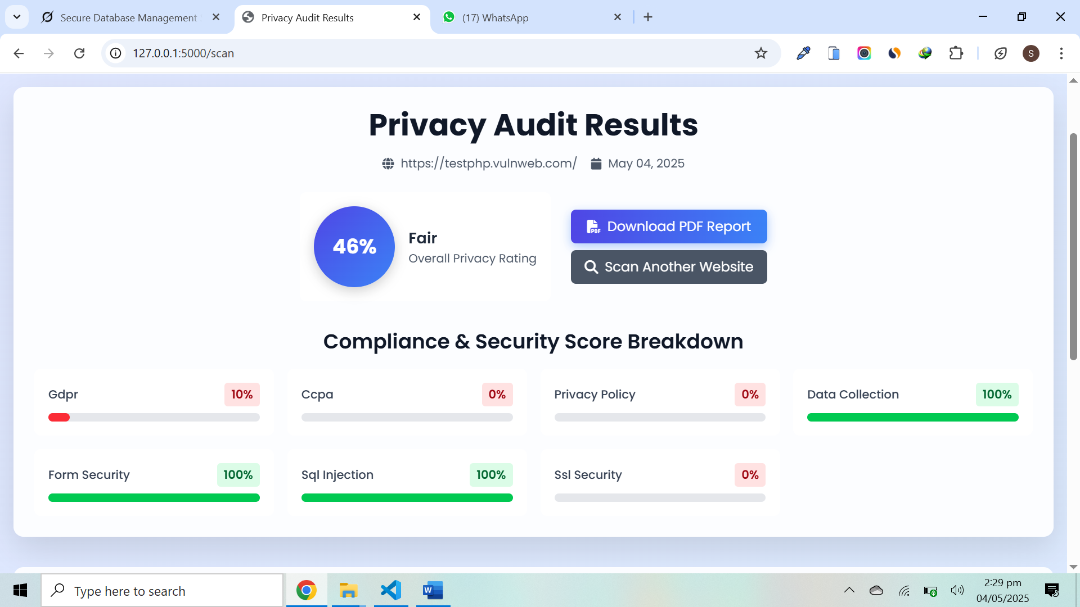
- Non-HTTPS Site: A site using HTTP (e.g., http://testfire.net)
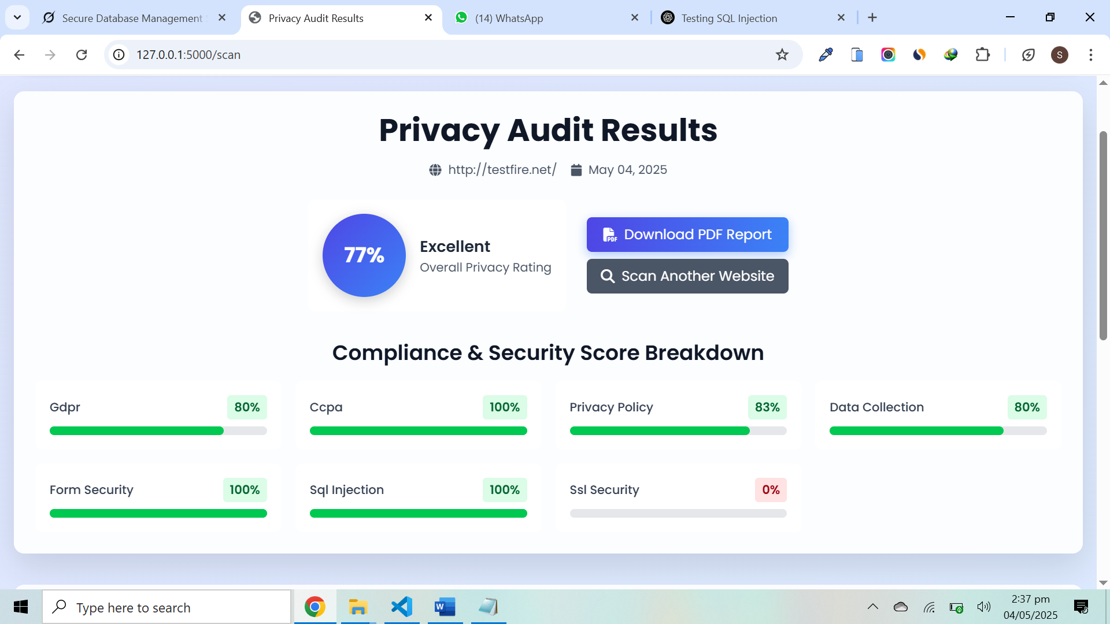
Information Security Highlights
Since this is an information security project, the following features emphasize security best practices:
- Encryption: AES-CBC for credit card data and RSA for key encryption ensure robust protection.
- Secure Authentication: SHA-256 hashing with salts and token-based access prevent unauthorized access.
- Input Validation: Server-side checks for payment details and form inputs
- Privacy Policies & Cookies: Verify that the websites are following policies and regulations and also check the data collection with cookies
- Vulnerability Detection: SQL injection, SSL and form security tests identify real-world threats.
- Compliance: GDPR/CCPA checks align with legal standards, reducing regulatory risks.
Conclusion
The Website Privacy and Security Audit Tool is a powerful solution for evaluating website compliance and security. By combining automated scanning with robust security measures, it helps users identify and address privacy and security issues effectively. The project demonstrates a deep understanding of information security principles, including encryption, secure authentication, and vulnerability detection.

